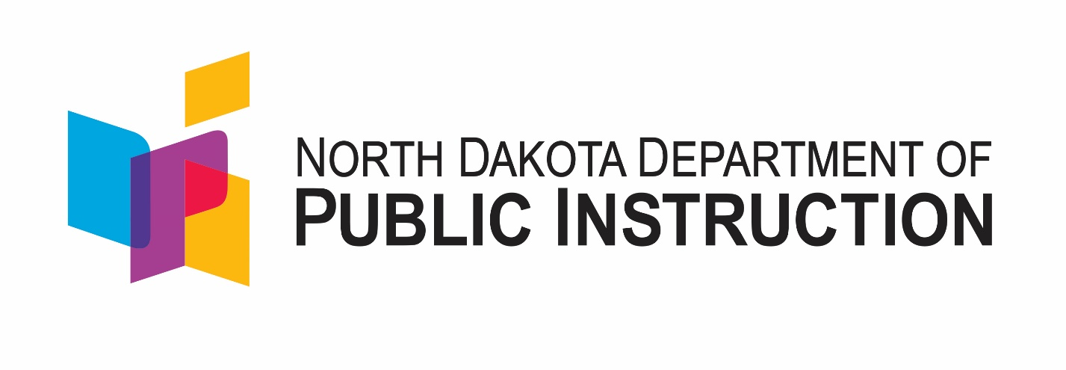

North Dakota Menu of Evidence-Based Interventions

April 2018

Stefanie Two Crow
Director Educational Equity and Support
Division of Student Support & Innovation
North Dakota Department of Public Instruction
600 East Boulevard Avenue Dept. 201
Bismarck, ND 58505-0440
www.nd.gov/dpi

The Department of Public Instruction does not discriminate on the basis of race, color, religion, sex, national origin, disability, age, sex (wages) or genetics in its programs and activities. For inquiries regarding nondiscrimination policies, contact Robert Marthaller, Assistant Superintendent, Department of Public Instruction, 600 East Boulevard Avenue, Dept. 201, Bismarck, ND 58505-0440, phone: (701) 328-2267.
North Dakota Educators,

The Every Student Succeeds Act (ESSA) was signed into law on December 10, 2015. It reauthorizes the 1965 Elementary and Secondary Education Act (ESEA), which was previously reauthorized as No Child Left Behind (NCLB) and is founded on the belief that all students can achieve when given strong educational supports.
In partnership with a broad and diverse group of stakeholders, the North Dakota Department of Public Instruction has created a new vision for education in North Dakota which reads “All students will graduate choice ready with the knowledge, skills and disposition to be successful in whatever they choose to do. This vision has been embedded in every aspect of North Dakota’s ESSA plan.
To increase the impact of educational investments by ensuring that interventions being implemented have proven to be effective in leading to improved student achievement, ESSA requires the use of “evidence-based interventions.” Practices of programs that have evidence that they are effective meet the criteria outlined in ESSA legislation are categorized into four tiers, or levels of evidence:
- Tier 1 – Strong Evidence: supported by one of more well-designed and well-implemented randomized control experimental studies
- Tier 2 – Moderate Evidence: supported by one or more well-designed and well-implemented quasi-experimental studies
- Tier 3 – Promising Evidence: supported by one or more well-designed and well-implemented correlational study, with statistical controls for selection bias
- Tier 4 – Demonstrates Rationale: practices that have a well-defined logic model or theory of action, are supported by research, and have some effort underway by a State Educational Agency (SEA), Local Education Agency (LEA), or outside research organization to determine their effectiveness
This guide is provided to assist schools and districts in selecting evidence-based interventions. This guidance document was created as a collaborative research project by NDDPI, Ed Direction/Frontline Education and NCCC.

Sincerely,

Stefanie Two Crow
Director Educational Equity & Support
Division of Student Support & Innovation
Table of Contents
Evidence-Based Interventions 5
Determining What Works the Best 6
What is an Effect Size? (And how do we know if it fits with the needs of our students?) 6
Expert Teaching Requires Practice 7
How Practice is Done Matters 7
Conditions for Success 8
Selecting Evidence-Based Interventions 9
Step 1: Identify Local Needs 9
Step 2: Selecting Relevant, Evidence-Based Interventions 10
Step 3: Plan for Implementation 11
Step 4: Implement 11
Step 5: Examine and Reflect 11
Appendix A: Literacy 13
National Reading Panel and Core State Standards 13
An example: Ed Direction Reading Framework 14
Example of Ed Direction’s Framework for Kindergarten through 3rd Grade 15
Summary of Research Supporting Effective Reading Interventions 19
Appendix B: Math 31
Concrete – Representation – Abstract: An Evidence-Based Model for Teaching Mathematics 31
Appendix C: At Risk Student Populations 32
Supports for Students with Disabilities 32
School Literacy Interventions 32
School Mathematics Interventions 32
Supports for Students Who Are Learning English 33
Supports for Native American Students 35
Schools and District Support Recommendations for Native American Students 35
Culturally-Responsive Teaching Strategies for Native American Students 36
State/National Programs and Initiatives for Native American Students 36
Examples of Exemplary Programs for Native Students 38
Appendix D: References to Interventions 39
School Literacy Interventions 39
School Mathematics Interventions 39
References 40
Appendix E: NDDPI ESSA Plan Resources/Support (pages 86-92) 44
Resources/Support for Comprehensive Schools 44
Resources/Support for Targeted Schools 45

Evidence-Based Interventions
In December 2015, Congress passed Every Student Succeeds Act (ESSA). Within the legislation are provisions with potentially revolutionary implications for education because they promote the use of federal dollars on programs with evidence of effectiveness.
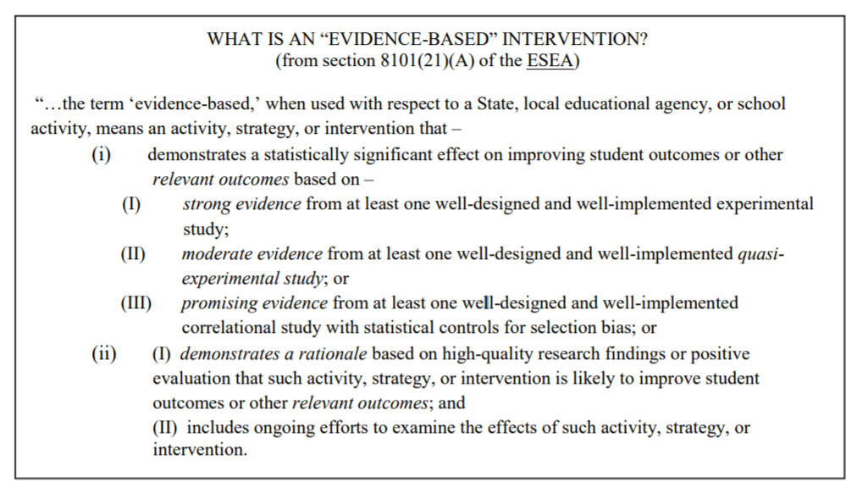
Federal law can be difficult to interpret, the following information is intended to clarify in teacher and principal friendly terms some key features of evidence-based interventions.
Practices of programs that have evidence that they are effective meet the criteria outlined in ESSA legislation are categorized into four tiers, or levels of evidence:
- Tier 1 – Strong Evidence: supported by one of more well-designed and well-implemented randomized control experimental studies
- Tier 2 – Moderate Evidence: supported by one or more well-designed and well-implemented quasi-experimental studies
- Tier 3 – Promising Evidence: supported by one or more well-designed and well-implemented correlational study, with statistical controls for selection bias
- Tier 4 – Demonstrates Rationale: practices that have a well-defined logic model or theory of action, are supported by research, and have some effort underway by a State Educational Agency (SEA), Local Education Agency (LEA), or outside research organization to determine their effectiveness

Determining What Works the Best
“How well teachers teach is the strongest influence on how well students learn.” -- John Hattie
Now, more than any time in history, professional educators have access to clear and accurate information about teaching strategies that work. By consistently implementing highly effective instructional strategies, teachers are more likely to increase students’ abilities to be college and career ready. In fact, a synthesis of over 913 meta-analyses, including 60,167 studies and 88,652,074 students, reported that the greatest influence on student learning is instruction (Hattie, 2013, p. 14).
Many instructional techniques have some impact on student performance, therefore, the question for today’s educator is not, “What works?” rather, “What combination of things works best?”
To find the answer to this question of what works best, educators can access meta-analysis research. The work of John Hattie, Robert Marzano, Viviane Robinson, Keith and Paula Stanovich, Robert Slavin, and Barack Rosenshine summarizes the effect size of a variety of instructional strategies. For this information to be useful, it’s important to understand what we can learn from Hattie’s analysis.

What is an Effect Size? (And how do we know if it fits with the needs of our students?)
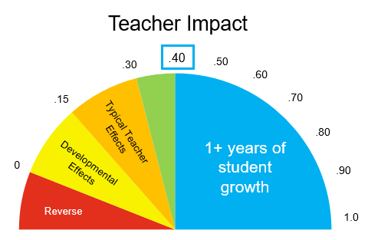

Typical effect sizes for instructional strategies range from .0 to .30, and those with an effect size of .40 or greater are associated with more than 1 year of growth in student performance. Simply put, if an instructional strategy has an effect size of .40, student growth in one year will be equal to, or greater than, one grade-level increase. With this logic, any instructional strategy with an effect size of .40 or higher that is implemented with fidelity will give students a better chance of catching up and narrowing gaps in achievement.
The effect sizes reported express the average change in student performance that is attributable to a specific instructional strategy. One can infer that no instructional strategy works equally well in all situations. However, the strategies presented are a good place to start when designing, implementing, and refining classroom instruction.

Expert Teaching Requires Practice
Teaching is a complex and sophisticated endeavor that requires practice and ongoing professional learning to maintain high levels of performance. As with any combination of skills worth practicing, the components of Evidence-Based Instructional Strategies in isolation may sound very basic. However, as professionals implement the components and become more fluent, more complexity is made apparent. When the instructional routine includes well connected Evidence-Based Instructional Strategies, teachers are more successful.

How Practice is Done Matters
Deliberate practice is a highly effective way for professionals to engage in a growth mindset and to continually improve the complex skills required for their work. A leading expert on the topic of deliberate practice, Anders Ericsson, has spent decades studying the differences between expert professionals and typical professionals in several fields. Ericsson has found that the level of expertise one achieves with a skill set has much to do with how one practices. Merely performing a skill many times does not translate into more expertise; deliberate practice is the secret sauce for developing and maintaining expertise.

According to the Marzano Center for Learning Sciences, educational professionals who successfully increase their expertise, through deliberate practice, do the following:
- Break down the specific skills into critical skill chunks
- Practice the skill on a day-to-day basis
- Make the practice public (consistently seen and heard by others) so actionable feedback can be received, and
- Continually increase the level of challenge with the intention of becoming an expert.
When engaging in deliberate practice a narrowed focus can be helpful. Marzano and colleagues found that teachers who focus on specific ‘thin slices’ of instruction and execute classroom strategies at a high level of skill are more likely to have a strong impact on student learning. The strategies selected are well suited for deliberate practice because they can be:
- broken into critical skill chunks,
- practiced every day,
- observed in action, and
- implemented with varied degrees of complexity, making them applicable for novice and expert teachers.

Conditions for Success
The effects of Evidence-Based Instructional Strategies on learning are highest in schools where:
  - Administrators strategically develop teacher leaders who are not afraid to examine current practices, acknowledging practices that are successful and problem-solving ways to address areas of concern.
  - An effective system to improve professional capacity, including making teachers’ classroom work transparent for examination by colleagues and coaches, to enable ongoing feedback and support, is nurtured.
  - A coherent instructional guidance system is implemented to ensure a viable curriculum and high expectations for all students, including coordination within and across grade-levels.
  - Administrators, teachers, support staff, and parents are united in their proactive development of a school climate that is inclusive, supportive of all students, and, an exemplary model for Positive Behavioral Interventions and Supports (PBIS).

Selecting Evidence-Based Interventions
The U.S. Department of Education’s Non-Regulatory Guidance: Using Evidence to Strengthen Education Investments, lays out a multi-step process in order to maximize the effectiveness of selecting and using proven programs and practices.
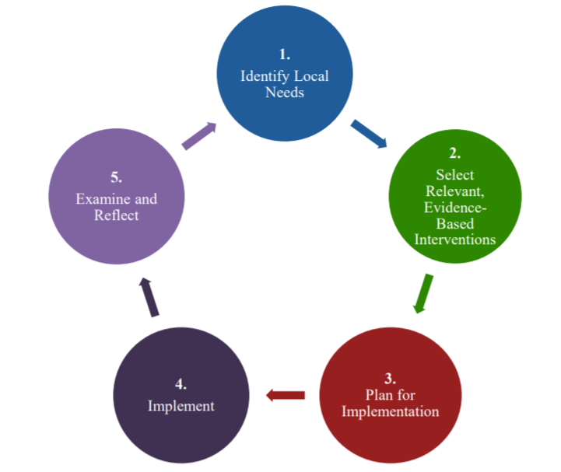
Figure 2:

Step 1: Identify Local Needs
Local Education Authorities (LEAs) should engage in timely and meaningful consultation with a broad range of stakeholders and examine relevant data to understand the most pressing needs of students, schools, and/or educators and the potential root causes of those needs.

Some questions to consider:
- Which stakeholders can help identify local needs and/or root causes?
- What data are needed to best understand local needs and/or root causes?
- How do student outcomes compare to identified goals? Are their inequities in student resources or outcomes within the district and/or school?
- What are potential root causes of gaps with performance goals and/or inequities?
- How should needs be prioritized when several are identified?
Potential resources to assist schools and/or districts with this important process include:
- North Dakota Department of Public Instruction personnel and ESSA website: https://www.nd.gov/dpi/SchoolStaff/SSI/ESSA/
- AdvancED accreditation reports: www.advanc-ed.org
- Ed Direction Improvement and Leadership Coaches: www.eddirection.com
- NDMTSS: https://www.nd.gov/dpi/SchoolStaff/SpecialEd/mtss/

Step 2: Selecting Relevant, Evidence-Based Interventions
Once needs have been identified, districts, schools, and other stakeholders will need to determine the interventions that will best serve their needs. By using rigorous and relevant evidence and assessing the local capacity to implement interventions, including funding, staff, staff skills, and stakeholder support, implementation is more likely to be done successfully.
- While ESSA requires “at least one study” on an intervention to provide strong-, moderate-, or promising-evidence, the entire body of relevant research should be considered.
- Interventions supported by higher levels of evidence are more likely to improve student outcomes because they have been proven effective through scientifically-based research.
- When strong- or moderate-evidence is not available, promising-evidence may suggest that an intervention is worth exploring.
- Interventions with little evidence should at least demonstrate a rationale for how they will achieve their intended goals and be examined to understand how they are working.
- The relevance of the evidence – specifically the setting (i.e. elementary, middle, and/or high school) and/or student characteristics (i.e. students with disabilities, English Learners, students who reside in low-income situations, and specific racial and or ethnic groups) may predict how well an evidence-based intervention will work in a specific school and/or district setting.
- The What Works Clearinghouse (WWC) uses rigorous standards to review evidence of effectiveness on a wide range of interventions and summarizes the settings and student characteristics are summarized. See Appendix A-G for additional resources. Also see North Dakota Department of Public Instruction Interactive tool for selecting evidence-based interventions.
- Local capacity to implement helps predict the success of an intervention, this includes available funding, staff resources, staff skills, and support for interventions. These variables should be considered when selecting an evidence-based intervention.

Some questions to consider:
- Are there interventions supported by strong- or moderate-evidence?
- What do the majority of studies on this intervention find? Does the intervention have significant effects on important student or other relevant (e.g. teacher leadership) outcomes?
- Were studies conducted in settings and with groups of students who have characteristics that are relevant to the local setting (i.e. students with disabilities, English Learners, students who reside in low-income situations, and specific racial and or ethnic groups)?
- If strong- or moderate-evidence is not available, is there promising evidence?
- Does the intervention demonstrate a rationale that suggests it may work, through a logic model that is supported by research?
- What resources are required to implement this intervention?
- Will the potential impact of this intervention justify the costs, or are their more cost-effective interventions that will accomplish the same outcomes?
- What is the local capacity to implement, including available funds, staff skills, and other supports for intervention?
- How does this intervention fit into the larger strategic goals and other existing efforts?
- How will this intervention be sustained over time?

Step 3: Plan for Implementation
An implementation plan that is developed with input from stakeholders sets up the district and/or school for success. Implementation plans should align with the NDDPI requirements for school improvement plans. For those schools engaged in Comprehensive School Support, Ed Direction will assist schools in completing the application and developing 90-, 60-, or 30-day implementation plans based upon the level of support your district/school selects. For schools selected for Targeted Support, NDMTSS support and opportunities in collaboration with the REAS.

Effective implementation plans include:
- A clear connect to the root cause(s) identified in Step 1 with well-defined desired outcomes for students and adults.
- Well defined, measurable goals
- Outlined roles and responsibilities for those involved
- Timelines for successful implementation
- Resources required to support the intervention
- Strategies to monitor performance and ensure ongoing improvement. This includes plans for data collection, analysis, and intervention

Questions to consider:
- How will the implementation plan be communicated to stakeholders?
- What supports are needed for adults to learn and implement selected interventions?
- Are the plans clear enough to reflect a feasibly narrow focus that can be understood by all stakeholders?
- Who will be responsible for monitoring the plan and what data are needed to evaluate effectiveness?

Step 4: Implement
All the improvement efforts are useless if students do not experience changes in their day-to-day instruction. For this reason, all stakeholders should be apprised of the implementation process and outcomes.

Questions to consider:
- What information will be collected to monitor the quality of implementation?
- How will stakeholders be informed of implementation progress?
- How will district and/or school know, on a regular basis, how implementation is going?

Step 5: Examine and Reflect
There are many ways to examine how interventions are working. The two essential sources of data and information include: 1). Student outcome data and 2). Implementation data. Student outcome data are collected directly from students; for example, assessment and survey results. Implementation data paint a picture of how the adults are learning and growing as professionals; for example, observations, self-reflections, and artifacts like student work.

Questions to consider:
- What are reasonable expectations of success and how can success be measured?
- What are the interim performance milestones that can be tracked?
- What have the students and educators shared about their experience and how the intervention is implemented?
- Is outside assistance needed to effectively measure implementation?
- How can coaching and professional learning be leveraged to increase the success of the intervention?
- What is the role of principals and teacher leaders in the measurement of implementation?
- How will the district/school determine next steps; for example, should the intervention continue, be modified, or be discontinued in favor of other alternatives?

Appendix A: Literacy

National Reading Panel and Core State Standards
Teaching reading is complex, the evidence-base reveals an active process that requires teachers to practice a growth mindset and set a tone that builds a literate community of thinkers, expressers, listeners, and learners, is essential. A good reading program of study includes:

Explicit instruction phonological awareness  Systematic phonics instruction including a focus on multi-syllabic words for older students | Ways to enhance comprehension of both literature and informational text  Methods to improve fluency: rate and accuracy
In addition to explicit reading instruction, literate students are also exposed to a program of study that includes:
- Consistent instruction on academic vocabulary and syntax, including practice speaking, listening, writing, reading
- Learning tasks that teach language structure and function
- Writing instruction that includes:

it is possible to develop the skills of all students by delivering explicit, scaffolded, and differentiated literacy instruction.

An example: Ed Direction Reading Framework
Education Direction’s Literacy Model can serve as a framework to structure a literacy block to include whole group and strategically grouped instruction, with particular attention to writing focused instruction. Examples of teacher-led instruction and student learning tasks are also suggested. Figure 3 shows a range of time for each type of instruction; a teacher’s lessons should be timed to meet the district or charter guidance and principal requirements. Additionally, the time listed is cumulative not consecutive, ideally students move between the 3 types of instruction multiple times during a single lesson.

Figure 3.
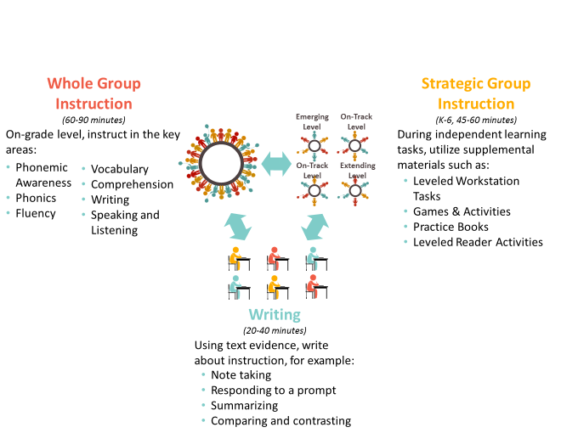

Example of Ed Direction’s Framework for Kindergarten through 3rd Grade

Skill/  Class Configuration | Teacher-Led Instruction | Examples of Student Learning Tasks
Phonemic Awareness  10-15 minutes  Whole Group | - Practice differentiating voiced and unvoiced speech sounds.  - Practice listening to sequences of sounds.  - Develop students’ ability to attend to differences between what they expect to hear and what they actually hear.  - Introduce students to the nature of syllables by leading them to clap and count the syllables in their own names.  - Extend awareness of initial phonemes by asking students to compare, contrast, and eventually identify the initial sounds of a variety of words. | - Students put their hands on their throat to feel the difference between phonemes that make the vocal cords vibrate (voiced) and those that do not (unvoiced)  - Using familiar poems or rhymes, change any text in both subtle and obvious ways at a number of different levels including phonemes, words, grammar, and meaning (i.e., Twinkle, twinkle little car)  - Students identify the beginning, middle, or ending sounds in words
Phonics  15-20 minutes  Whole Group | - Explicitly and systematically instruct students in how to relate letters and sounds, how to break spoken words into sounds, and how to blend sounds to form words.  - Teach letter-sound relationships explicitly and in isolation.  - Provide opportunities for children to practice letter-sound relationships.  - Help students understand why they are learning the relationships between letters and sounds.  - Help students apply their knowledge of phonics as they read words, sentences, and text.  - Help students apply what they learn about sounds and letters to their writing. | - Alphabetic letter recognition (i.e., naming and matching letters of the alphabet)  - Blending sounds to make words  - Matching phonemes to graphemes  - Blending/segmenting syllables in words  - Reading high-frequency words made from tactile letters and finding them in print  - Read decodable texts with phonics spelling patterns
Fluency/  Oral Reading Fluency  25-30 Minutes  Whole Group | - Model fluent reading and demonstrate phrasing of texts in a variety of ways.  - Facilitate daily repeated timed readings of familiar text, such as outlined in the 6-Minute Solution program.  - Provide opportunities for independent silent reading of text at students’ “independent” reading level.  - Provide direct instruction and feedback to teach correct expression and phrasing, and strategies that fluent readers use.  - Use guided oral reading using an assortment of expository and literary texts to promote fluency.  - Scaffold student fluency practice from the sub, word, sentence, and text levels to facilitate familiar reading.  - Implement word study activities to build accuracy. | - Choral reading  - Partner reading  - Reader’s theatre  - Audio-assisted reading  - Shared Reading  - Timed repeated readings with both expository and literary texts (e.g., education periodicals, magazine articles, textbooks, fluency reads, online resources, etc.)
Word Knowledge/  Vocabulary  25-30 minutes  Whole Group | - Explicitly teach vocabulary strategies, sounds, patterns, concepts, and meanings using literary and informational texts with emphasis on high-quality classroom language, reading aloud to students, and wide independent reading.  - Illustrate the words with examples (concrete, visual, verbal).  - Use context (e.g., cause/effect relationships and comparisons in text) as a clue to the meaning of a word or phrase.  - Model how good readers use context clues to identify word meanings.  - Use meaningful parts of the word as clues to meaning of the word (e.g., common, grade-appropriate Greek and Latin affixes and roots; compound words; word families).  - Connect new words with known concepts including comparing and contrasting new words with known words.  - Consult reference materials such as dictionaries, glossaries, or thesauruses to find the pronunciation and determine or clarify the precise meaning of key words and phrases.  - Develop understanding of figurative language, word relationships, and nuances in word meanings including figures of speech.  - Provide multiple exposures to vocabulary words (review and reinforce).  - Implement instructional activities that allow students to use and identify meanings of new words in a variety of ways and in rich contexts.  - Highlight targeted vocabulary through scaffolded questioning or comments (to engage students in learning).  - For ELs: Take advantage of students’ first language when teaching vocabulary (cognates). | - Word Sorts (by sound, pattern, concept/meaning)  - Build meaning behind the prefixes, suffixes, and root words (Greek or Latin)  - K-W-L Charts  - Semantic Word Maps  - Student-friendly explanations  - Word Banks/Vocabulary Logs  - Yes/No/Why  - Word Pairs  - “Meaningful Sentence” Writing  - Word Wall  - Word Hunts  - Practice spelling words through various research-based activities (e.g., word study)  - Vocabulary Notebook (e.g., add Tier 2 words and represent their meaning with pictures and words)  - Apply newly learned word knowledge across the content areas through writing and reading
Comprehension  25-30 minutes  Whole Group | - Explicitly teach essential skills and strategies for reading comprehension with frequent opportunities for practice.  - Focus on word-to-text integration (the connection of the meaning of a word, as it is read, to a representation of the text).  - Facilitate Close Reading with text-dependent questions.  - Use a variety of oral reading strategies (e.g., partner reading, cloze reading, choral reading).  - Implement instructional activities that allow students to engage in discussion.  - Focus on Reading Literature (RL), Reading Information (RI), and Speaking & Listening Standards. | - Text Preview (i.e., surveying the title, illustrations, and unusual text structures) to make predictions  - Think, talk, and write about the topic of the text  - Graphic Organizers  - Concept Maps/Sorts  - Think-Pair-Share  - Oral Readings (e.g., partner reading, cloze reading, choral reading, dramatic reading)  - Discuss and respond to text-dependent questions  - Book Talks  - Summarizing  - Sequencing  - Shared Reading  - Read-Alouds  - Paraphrasing or restating important and/or difficult sentences and paragraphs  - Exit Slips
Speaking & Listening  Embedded Throughout Instruction  Whole Group  *Spoken language is at the heart of much human interaction, at home, at work and in society. Speaking and listening skills are important in all contexts. | - Demonstrate appropriate ways to speak and listen, ask and answer questions, and give and follow directions.  - Model/think aloud specific to the content being taught.  - Engage students in lengthy conversations about academic content.  - Plan for students to actively participate in speaking and listening activities throughout instruction.  - Teach students how to use appropriate facts and relevant, descriptive details to support main ideas or themes using various speaking types (e.g., comprehension, collaboration, presentation). | - Engage in a range of collaborative discussions (i.e., one-on-one, in groups, and teacher-led)  - Differentiate between contexts that call for formal English (e.g., presenting ideas) and situations where informal dialogue is appropriate (e.g., small-group discussion); use formal English when appropriate to task and situation  - Report on a topic or text, tell a story, or recount an experience in an organized manner  - Utilize discussion strategies and structures such as Think, Pair, Share, Jigsaw Groups, Philosophical Chairs, etc.  - Assign student roles in discussion groups  - Provide sentence frames for students to scaffold the use of academic language

Summary of Research Supporting Effective Reading Interventions

Intervention | Level of Evidence | Summary of Research | Students Who Benefit | Reference(s)
Phonemic awareness instruction | Strong | - The National Reading Panel found positive effects of phonemic awareness (PA) instruction on improving students' ability to apply phonemic awareness in their reading and spelling. Learning to manipulate phonemes in words helped the students learn to read. | - Kindergartners and 1st graders (learning to spell)  - Children at risk for future reading problems and normally developing readers  - Low SES and mid-to-high SES children (boosting spelling skills)  - Children learning to spell in English and children learning in other languages  - ("PA instruction was not effective for improving spelling in disabled readers. This is consistent with other research indicating that disabled readers have a difficult time learning to spell.") | Eunice Kennedy Shriver National Institute of Child Health and Human Development, NIH, DHHS. (2000).  Report of the National Reading Panel: Teaching Children to Read: Reports of the Subgroups (00-4754).  Washington, DC: U.S. Government Printing Office.
Vocabulary Programs | Strong (d=.67) | • Vocabulary instructions and knowledge of word meanings help growth in reading comprehension.  • The most effective vocab teaching methods included providing both definitional and contextual information involved students in deeper processing.  • Mnemonic keyword method had positive effects on recall of definitions and sentence comprehension.  • Language intervention programs were found to have immediate and positive gains for students with intellectual disabilities.  • Language interventions used with students with language disorders increased outcomes and achievement significantly – in both pragmatic language and syntax functions.  • Greater degree of improvement where modelling was used.  • The meta-analyses showed that vocabulary programs are beneficial in developing reading skills and comprehension. d=.67 | - Low Achieving students (Reading)  - Students with Disabilities  - Students experiencing difficulties in reading  - EL Students | Hattie, John (2009) Visible Learning: A synthesis of over 800 meta-analyses relating to achievement. Routledge Pgs. 131-132
Phonics Instruction | Strong (d=.60) | - Alphabetical code and knowledge needed to read words  - Sequential phonics programs beneficial – short and long. vowel sounds, letter blends, consonant diagraphs, etc.  - One meta-analysis concluded that systematic learning of phonics is essential to teaching reading and that letter-sound correspondence must be known to read and spell words.  - Phonics instruction should be administered in the early years of school to children who are having difficulty learning to read.  - Two types of teaching had great effects: teaching to manipulate phonemes using letters and a synthetic phonics program that emphasized students converting letters into sound then blending sounds to form recognizable words and analyzing blends and phonemes in their word.  - More effective when delivered in small tutorial groups or as whole class activities.  - The effects of phonemic training were discernable for approx. 18.5 months.  - Teaching in groups had more effect than individual teaching (1-1).  - Program that combined phonological and letter ID training were more effective than phonological training alone.  - Programs were more effective with early learners and effects decreased as age increased.  - Phonics programs with additional language and literacy activities were most effective with the core skills being focused on phonics, fluency and comprehension.  - Phonics training is effective for all students of any socio-economic status.  - Direct instruction is the most effective delivery method for phonics programs.  - SWD benefit from direct teaching of phonics for word recognition.  - Rapid letter and sound ID were highly related to reading and comprehension skills.  - Overall – phonics instruction is powerful for developing both reading and comprehension skills. d=.60 | - Low Achieving students (Reading)  - Students with Disabilities  - Students experiencing difficulties in reading  - EL Students | Hattie, John (2009) Visible Learning: A synthesis of over 800 meta-analyses relating to achievement. Routledge Pgs. 132-134
Repeated Reading | Strong to moderate | - Re-reading a short, meaningful passage until a satisfactory level of fluency is reached.  - Chard, Vaughn and Tyler (meta 2002) saw that variance in the test format (e.g., timed vs untimed changed outcomes. Timed tests showed a student capacity to (more) automatically apply word recognition and decoding skills.  - These skills become automatic in average children about Gr 2 or 3, however these skills need to be taught to SWLD ongoing.  - The skill of automaticity in word recognition and decoding needs to be specifically assessed and taught.  - The concept of automaticity appears in all second and third chance programs (CR/RR etc.).  - Therrien (2004) found that the effects of RR had marked positive effects on reading comprehension and fluency – although effects were more immediate than long term. | - Low achieving students  - Students with learning disabilities | Hattie, John (2009) Visible Learning: A synthesis of over 800 meta-analyses relating to achievement. Routledge Pg. 135
Comprehension Programs | Strong (d=.58) | - Rowe’s meta (1985) – programs that focused on processing strategies (inferential rules, summarizing, chunking texts etc.) produced higher outcomes than those focused only on word meanings.  - Sencibaugh (2005) looked at two programs, one using mainly visual strategies and one using mainly auditory strategies – and found that both had positive effects especially when teachers used both strategies to augment reading comprehension teaching.  - Walber, Karegianes and Rasher (1980) found that when comp was combined with phonics programs, outcomes were strong.  - Guthrie, McRae and Klauda (2007) reviewed the ‘concept orientated’ reading program where the reader is internally motivated to read due to interest – the program included writing linked to reading and topic – and found positive results for comprehension, fluency, story comprehension, and motivational outcomes such as curiosity and willingness to learn.  - A meta-analysis done on words read during normal reading (and when using ‘high frequency’ word lists) showed that poor readers learn only about 15% of previously unknown words they come across (Swanborn and Glopper, 2002). Average students had higher outcomes when learning words incidentally through reading. | - Students falling behind in reading  - Low achieving students  - SWLD  - EL Students | Hattie, John (2009) Visible Learning: A synthesis of over 800 meta-analyses relating to achievement. Routledge Pg.136-137
Exposure to Reading | Moderate | - Studies showed that the effect of being read ‘to’ have varying effects depending on who is doing the reading and for what purpose (parent, teacher, volunteer).  - Teachers have the most effect as reading ‘to’ students generally meant that they are also engaged in activities that include probing questions to ensure students are following and making meaning of the text (Blok 1999) (.63 oral language and .41 reading).  - These effects were higher with smaller groups of students.  - Sustained silent reading, time alone on task – much lower effects.  - Parents reading to children has positive effects on their reading on vocab acquisition.  - Parent-Child reading in the early years supported children’s literacy orientation – parent-preschooler reading positively affected language growth, emergent literacy and reading achievement.  - As children became more able to read on their own, most positive effects of parent shared reading diminished.  - Reading to children must be complemented by instruction linked to text for readers above pre-school level.  - Torgerson, King and Sowden (2002) found that volunteers reading to student in the classroom had little effect on reading development.  - Yoon (2002) found that silent reading for poor readers, above Gr 3 level, had very little effect on skill development and confirmed for those students that reading is something not enjoyable. | - Students up to and including Grade 3  - Low achieving students  - SWLD  - EL Students | Hattie, John (2009) Visible Learning: A synthesis of over 800 meta-analyses relating to achievement. Routledge Pgs. 138-139
Guided repeated oral reading procedures | Strong (d=.41) | - The National Reading Panel found that guided oral reading procedures had positive effects on reading fluency and overall reading achievement, including word recognition, fluency, and comprehension.  - The overall weighted effect size average was 0.41, indicating guided oral reading procedures have a moderate impact on student reading achievement. | - Students through at least grade 3  - Students with various kinds of reading problems throughout high school | Eunice Kennedy Shriver National Institute of Child Health and Human Development, NIH, DHHS. (2000).  Report of the National Reading Panel: Teaching Children to Read: Reports of the Subgroups (00-4754).  Washington, DC: U.S. Government Printing Office.
Provide opportunities for extended discussion of text meaning and interpretation | Moderate | - The underpinning theory is that students can and will internalize thinking processes experienced repeatedly during discussions. In high-quality discussions students have opportunities to express their own interpretations of text and to have those positions challenged by others. During an effective discussion, students are presented with multiple examples of how meaning can be constructed from text.  - Studies show the most effective practices occurred when students combined reading with practicing the application of compression strategies such as summarizing and making predictions.  - The most convincing evidence came from studies where reading texts was sustained and in depth rather than short question and answer sessions. The use of 'authentic' questions, perhaps linking student experience to texts was most effective.  - It was noted that teachers who provided many opportunities for student to work together to “sharpen their understandings with, against, and from each other.”  - The link provided is a report which also gives teachers guides and recommendations for implementing this intervention. | - At risk students in Grades 4 through 12 (can be adapted for lower grades) | Kamil, M. L., Borman, G. D., Dole, J., Kral, C. C., Salinger, T., & Torgesen, J. (2008). Improving Adolescent Literacy: Effective Classroom and Intervention Practices. IES Practice Guide. NCEE 2008-4027. National Center for Education Evaluation and Regional Assistance.
Explicit Vocabulary Instruction | Strong | - Learning specialized vocabularies (subject or content focused) contributes to the success of students. Although most students learn words incidentally as they read, the probability for students at risk or SWLD doing so is low therefore additional explicit instruction is required.  - Words are best learned through repeated exposure and instruction in multiple contexts. Explicit vocabulary instruction is an umbrella term for two major approaches; direct instruction in word meaning and, instruction in strategies to promote independent vocabulary acquisition.  - Use of dictionaries and glossaries is a feature of explicit strategy instruction as is the use of graphic displays and semantic maps. Research shows that both approaches can effectively promote students' vocabulary.  - The link provided is a report which also gives teachers guides and recommendations for implementing this intervention. | - At risk students in Grades 4 through 12 (can be adapted for lower grades)  - EL Students | Kamil, M. L., Borman, G. D., Dole, J., Kral, C. C., Salinger, T., & Torgesen, J. (2008). Improving Adolescent Literacy: Effective Classroom and Intervention Practices. IES Practice Guide. NCEE 2008-4027. National Center for Education Evaluation and Regional Assistance.
Direct and Explicit Comprehension strategy instruction | Strong | - Four ideas about teaching comprehension from research are outlined for teachers: A number of different strategies have been showed to be effective, including; summarizing the main idea, asking questions about what has been read, drawing inferences that are based on texts and prior knowledge, answering questions at different stages of reading and using graphic organizers to organize ideas about what has been read.  - Many researchers think that it is not the specific strategy taught that makes the difference, but that it is the student's active participation in the comprehension process that makes the most impact on learning.  - Research cannot define which strategy is best, but that a combination and excellent teacher practice will define how effective the learning is.  - Multiple strategy training results in better comprehension than single strategy training.  - Findings of this research are consistent with that of the National Reading Panel (NRP).  - The link provided is a report which also gives teachers guides and recommendations for implementing this intervention. | - At risk students in Grades 4 through 12 (can be adapted for lower grades)  - EL Students  - Can be adapted based on the needs of SWLD | Kamil, M. L., Borman, G. D., Dole, J., Kral, C. C., Salinger, T., & Torgesen, J. (2008). Improving Adolescent Literacy: Effective Classroom and Intervention Practices. IES Practice Guide. NCEE 2008-4027. National Center for Education Evaluation and Regional Assistance.
Make available intensive and individualized interventions for struggling readers that can be provided by trained specialists | Strong | - Some adolescents need more support to increase literacy skills than regular classroom teachers can provide. Students who are unable to meet grade-level standards in literacy often require supplemental, intensive, and individualized reading intervention to improve their skills.  - Such interventions are most often provided by reading specialists or teachers who have undergone thorough training to help them understand the program or approach they will use and to deepen their understanding of adolescent struggling readers.  - The purpose of intensive interventions is to accelerate literacy development so that students can make substantial progress toward accomplishing reading tasks appropriate for their current grade level.  - Placement in interventions is often a two-step process, beginning with an initial screening assessment to identify those students who need extra help. This step should be followed by assessment with diagnostic tests to provide a profile of literacy strengths and weaknesses.  - Because the cause of adolescents’ difficulties in reading may differ from student to student, interventions may focus on any of the critical elements of knowledge and skill required for the comprehension of complex texts. These elements include: fundamental skills such as phonemic awareness, phonemic decoding, and other word analysis skills that support word reading accuracy; text reading fluency; strategies for building vocabulary; strategies for understanding and using the specific textual features that distinguish different genres; and self-regulated use of reading comprehension strategies. | - At risk students in Grades 4 through 12 (can be adapted for lower grades)  - EL Students  - SWLD | Kamil, M. L., Borman, G. D., Dole, J., Kral, C. C., Salinger, T., & Torgesen, J. (2008). Improving Adolescent Literacy: Effective Classroom and Intervention Practices. IES Practice Guide. NCEE 2008-4027. National Center for Education Evaluation and Regional Assistance.
Make available intensive and individualized interventions for struggling readers that can be provided by trained specialists | Strong | - Determining students’ skill levels, helping students learn specific reading strategies, and providing intensive and individualized instruction appear to be especially promising methods for improving the outcomes of struggling readers. For example, students who have difficulty using the skills needed to recognize words need different intervention than do students whose primary deficits are figuring out the meaning of unfamiliar words or comprehension of extended prose.  - The link provided is a report which also gives teachers guides and recommendations for implementing this intervention. | - At risk students in Grades 4 through 12 (can be adapted for lower grades)  - EL Students  - SWLD | Kamil, M. L., Borman, G. D., Dole, J., Kral, C. C., Salinger, T., & Torgesen, J. (2008). Improving Adolescent Literacy: Effective Classroom and Intervention Practices. IES Practice Guide. NCEE 2008-4027. National Center for Education Evaluation and Regional Assistance.
Second/Third chance programs | Strong | - Corrective Reading.  - Reading Recovery (greater outcomes).  - D’Agostino and Murphy (2004) found that students participating in RR outperformed those in the control group and that the program showed the best, sustained effects for students in Gr 1 who were in the lowest performing group with positive effects still evident at the end of Gr 2.  - Students ‘at risk’ who participated in the programs also showed growth.  - The highest effect size for RR was at d=.96 where RR was used as a supplemental program, not a substitute for classroom instruction in reading. | - Student at-risk  - Low achieving students  - SWLD  - EL Students | Hattie, John (2009) Visible Learning: A synthesis of over 800 meta-analyses relating to achievement. Routledge Pgs. 139-140
Increase student motivation and engagement in literacy learning | Moderate | - To foster improvement in adolescent literacy, teachers should use strategies to enhance students’ motivation to read and engagement in the learning process. Teachers should help students build confidence in their ability to comprehend and learn from content area texts.  - They should provide a supportive environment that views mistakes as growth opportunities, encourages self-determination, and provides informational feedback about the usefulness of reading strategies and how the strategies can be modified to fit various tasks.  - Teachers should also make literacy experiences more relevant to students’ interests, everyday life, or important current events.  - Correlational evidence suggests that motivation to read school-related texts declines as students’ progress from elementary middle school.  - The strongest decline is observed among struggling students.  - When teachers put more emphasis on the learning process and provide a supportive environment where mistakes are viewed as growth opportunities instead of failures, students are more likely to develop learning goals.  - Studies have consistently shown that students who have learning goals are more motivated and engaged and have better reading test scores than students who have performance goals.  - The link provided is a report which also gives teachers guides and recommendations for implementing this intervention. | - At risk students in Grades 4 through 12 (can be adapted for lower grades) | Kamil, M. L., Borman, G. D., Dole, J., Kral, C. C., Salinger, T., & Torgesen, J. (2008). Improving Adolescent Literacy: Effective Classroom and Intervention Practices. IES Practice Guide. NCEE 2008-4027. National Center for Education Evaluation and Regional Assistance.

Appendix B: Math

Concrete – Representation – Abstract: An Evidence-Based Model for Teaching Mathematics

Effectively teaching math requires a deliberate focus on solving complex problems, using tools and models strategically to make sense of abstract ideas, and critiquing mathematical logic and reasoning so students most effectively learn. Research shows we can accomplish this using the Concrete – Representational – Abstract model (CRA). When using the Concrete – Representational – Abstract model students perform beyond just getting the right answer. Students are able to demonstrate mathematical understanding, apply procedures to other scenarios, and justifying their thought processes.
- Concrete Modeling: Using concrete materials to model problem solving
- Representational (Pictorial): Transforming the concrete model to a representational model using pictures, virtual manipulatives, drawings, etc.
- Abstract: Modeling the concept symbolically, using only numbers, notation, and mathematical symbols
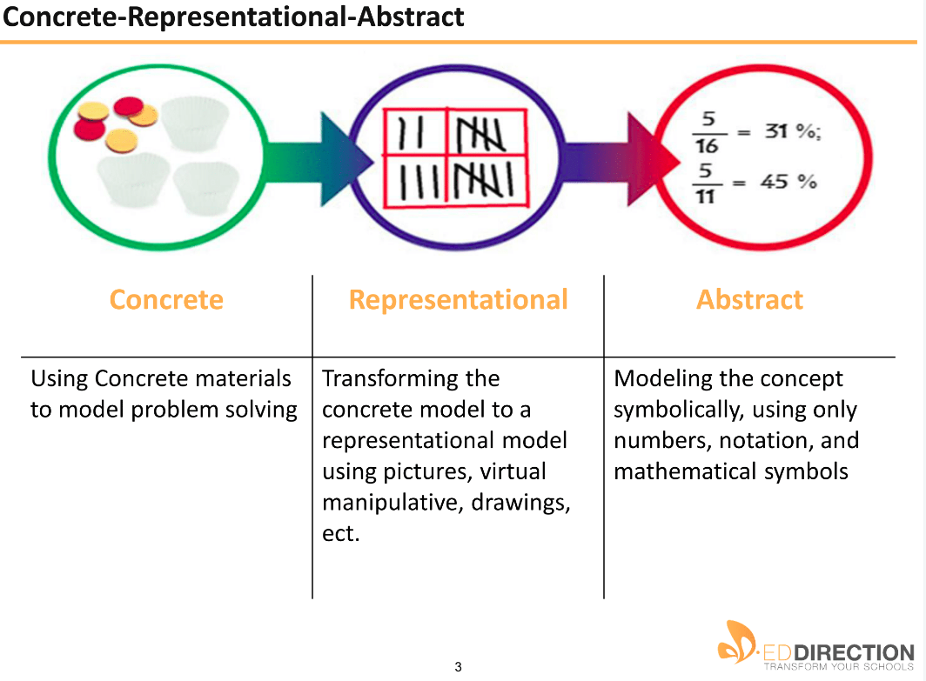
Figure 4: Ed Direction example of CRA model

Appendix C: At Risk Student Populations

Supports for Students with Disabilities

School Literacy Interventions
- Design instruction according to Universal Design principles: multiple means of engagement, multiple means of response, multiple means of access to content material
- Use of assistive technology to provide access to content material- text to speech, e-readers

Ongoing embedded professional development in how to:
  - Use evidence-based content enhancement strategies like those proposed by Donald Deschler and Jean Schumaker,
  - Embed scaffolds and supports to increase literacy independence,
  - Match readers to text
  - Implement metacognitive teaching and cooperative learning strategies like Cooperative Integrated Reading and Composition (CIRC) , Peer Assisted Learning Strategies (PALS) and Direct Instruction/Corrective Reading
  - Diagnose reading difficulty (s) and identify evidence based appropriate interventions
  - Implement interventions with fidelity
  - Collection and analysis of data to make instructional decisions
  - Use questions to improve student comprehension and question-answer relationships
  - Build background knowledge and vocabulary
  - Locate accessible instructional materials- Bookshare, NIMAC and North Dakota Vision Services/School for the Blind
  - Evaluating instructional materials for accessibility
- Direct vocabulary instruction and word learning strategies
- Direct explicit instruction regarding content text features, adjusting reading rate according to text demands, extracting meaning from complex texts, and content literacy processes
- Direct explicit instruction on the application and use of newly acquired reading skills
- Daily exposure to a fluent adult reader reading aloud
- Provide multiple opportunities to read and discuss text

School Mathematics Interventions
- Design instruction according to Universal Design principles: multiple means of engagement, multiple means of response, multiple means of access to content material
- Use of assistive technology to provide access to mathematics texts - text to speech, e-readers
- Systematic and explicit instruction in the use and application of mathematical processes and problem-solving strategies
- Direct instruction in how to read and work within the language of mathematics, especially vocabulary, symbols and diagrams
- Direct instruction in the structure and semantic clues of word problems

Ongoing professional development on:
  - Developing prompts and solution-oriented questions to promote self-instruction
  - Implementing an effective peer tutoring program for mathematics with students with disabilities: Class wide Peer Tutoring (CWPT), Peer Assisted Learning Strategies (PALS) or Reciprocal Peer Tutoring (RPT)

Designing highly structured activities or teaching routines for peer tutoring sessions:
  - Using the Concrete-Representational-Abstract techniques incorporating manipulatives and other visual representations
  - Collection and analysis of data to make instructional decisions
  - Understanding the components of instructional episodes: pacing, feedback, responses, listening and monitoring
  - Using mnemonics and other scaffolds to promote self-monitoring of learning and self-instruction
  - Understanding the influence reading difficulties have on success in mathematics and identifying strategies to mitigate this influence
  - Developing systematic instructional strategies for teaching the language of mathematics, especially its vocabulary
  - Developing a common pedagogy and progression of mathematics instruction within the school and grade level
  - Developing a common process for students to justify or explain their work and multiple opportunities to do so

Supports for Students Who Are Learning English
The North Dakota Department of Public Instruction offers the following list of interventions, strategies, and resources as a menu for focus and priority schools, as well as those not meeting their Annual Measurable Objectives (AMOS). This list is not inclusive, but rather a menu of potential options. Districts and schools may select their own interventions or choose from the following state generated list.
- Supplemental Educational Services: Supplemental Educational Services (SES) is additional academic instruction designed to increase the academic achievement of students in low-performing schools. They must be provided outside the regular school day and are specifically focused on increasing the academic achievement of students. If North Dakota’s ESEA Flexibility Waiver is approved, districts are no longer required to set aside up to 20% of their Title I funds for SES. However, many schools have seen student academic success through the SES program and it remains an option for those schools that elect to offer students SES services.
- Response to Intervention (RTI): Response to Intervention (RTI) is the practice of providing high-quality instruction and interventions matched to student need, monitoring progress frequently to make decisions about changes in instruction or goals, and applying student response data to important educational decisions. RTI can be applied to decisions in general, remedial and special education creating a well-integrated system of instruction/intervention guided by student outcome data. RTI is at the forefront of methods being utilized as a process to help raise the academic achievement of at-risk students. www.dpi.state.nd.us/title1/response.shtm
- Title I “What Works” Document: The state Title I office has created this “What Works” resource guide for schools and districts to provide educators with strategies, interventions, and components used in effective educational programs. This document contains 22 one-page profiles. Each of these profiles provides an overview, research summary, and resource section on educational topics being used across the nation to improve education and raise academic achievement. The resources within this document are provided to assist schools and districts in their school improvement efforts. www.dpi.state.nd.us/title1/resources.shtm
- Title I School Improvement Project: The state Title I office contracted with distinguished educators to create a toolbox of exemplary school improvement practices and strategies. These documents outline a specific school improvement activity, provide the supporting research, and offer a sample budget for schools and districts to reference while developing their own school improvement initiatives. www.dpi.state.nd.us/title1/project.shtm
- Instructional Coaches: The use of instructional coaches can be a powerful intervention with great potential to improve teacher performance and raise academic achievement. www.dpi.state.nd.us/title1/coaches.shtm
- Title I Research/Resource Report: This site contains both past and current issues of the Title I Research/Resources Report. In these documents, you will find a summation of newly released research and resources on educational issues relevant to North Dakota schools. www.dpi.state.nd.us/title1/RRR.shtm
- Parental Involvement Initiatives: Research provides convincing evidence that parents are an important influence in helping their children achieve high academic standards. Schools can support parental involvement through activities such as the following:
  - Designate a staff member as a parental involvement coordinator.
  - Sponsor monthly parent-student nights with specific focus on how to help students.
  - Have a parental involvement coordinator create activity packets for parents to work with their children at home.
- Implement a Research Proven Instructional Program: Implementing a research proven instructional program (i.e., Read 180, FASTT Math) is used nationwide to provide additional academic support to students to increase academic achievement. Each model and program offers strategies and methods of increasing achievement and learning. Some models of intervention focus on specific subject areas, some on particular aspects of learning, some focus on environmental issues, and others attempt to cover all.
- Statewide System of Support (SSOS) Consultant Team: The state Title I office has compiled a list of consultants who can assist districts and schools with planning and implementing school improvement activities. These consultants are known as the Statewide System of Support (SSOS) Consultant Team. Team members must have expertise in a variety of school improvement areas to provide individualized assistance to schools. www.dpi.state.nd.us/title1/resource/support/SSOS.shtm
- Early Childhood Education (ECE) Services: Currently, there is a national focus on early childhood education. These programs can include preschool, jumpstart or junior kindergarten program, or full-day kindergarten program. Providing ECE interventions can reduce the need to remediate once children are in elementary school.
- After-School Programming: Implementing an after-school program can be powerful intervention for supporting the academic needs of low achieving students.
- Research Based Documentation Tool: www.dpi.state.nd.us/title1/resource/SBRR.pdf
- An Overview of Teaching Strategies for SBRR: www.dpi.state.nd.us/title1/resource/strategies.pdf
- Scientifically Based Reading Research Teacher Tools: www.dpi.state.nd.us/title1/targeted/general/reauthoriz/researchtool.pdf
- Best Practices and Teaching Ideas for the Mathematics Classroom: www.dpi.state.nd.us/title1/resource/bestprac.pdf
- Are You Concerned About Making AYP? Then, Look to The RESEARCH!: www.dpi.state.nd.us/title1/resayp.pdf
- Title I Summer School Program: Providing a summer school program is again an opportune way to provide additional interventions to low achieving students. A number of other resources on summer school programming is available on the Title I website at www.dpi.state.nd.us/title1/resource/aftrschl/index.shtm
- Data Analysis: Many districts and schools struggle to understand their data so they can target their areas of need. A review of data constitutes high quality professional development that can pinpoint areas of need.
- Study Groups: Study groups can be the foundation of your professional development program. This type of collegial work provides an opportunity for growth not realized when working in isolation in the classroom. When these individuals come together and focus on students learning, the range of knowledge, resources, and experience they bring to the process are blended together for a more powerful impact on all of their students. www.dpi.state.nd.us/title1/profdev/index.shtm

Supports for Native American Students
- Dropout prevention programs are needed in schools attended by Native American students
- High school equivalency programs (i.e., G.E.D.) are a high-priority education need identified by tribal elders
- Teachers should incorporate traditional Native approaches which emphasize cooperation and reflection
- Graduation rates can be positively influenced by the following:
  - active parent and community involvement programs
  - encouraging student proficiency in their Native language as well as in English
  - incorporating tribal culture, values and beliefs in instruction
  - encouraging student leadership and having a high-expectation mindset
- Teachers must know to incorporate Native American culture into classroom instruction
- Teachers must know how to nurture resilience and instill high self-esteem in students
- Students may benefit from the use of small-group or one-on-one tutoring settings
- Successful teachers tend to be those who immerse themselves in the community in which they teach

Schools and District Support Recommendations for Native American Students
- Provide professional development on culturally-responsive pedagogy – i.e., provide webinars that would increase awareness of culturally-relevant academic needs of Native American students
- Develop a culturally-relevant curriculum dealing with specific North Dakota tribal history, government, and culture
- Create awareness of Native American sovereignty issues among classroom teachers
- Increase community and parent engagement efforts through workshops and training sessions
  - Encourage schools to host Parent Nights for Native American parents and families
  - Provide community dinners to establish positive relationships with tribes and promote collaborative opportunities with local tribal governments
  - Support districts and schools in promoting home visitations for Native American students who are at risk or in need of intensive intervention
  - Provide wrap around services for Native American students that promote a holistic approach to academic achievement
- Develop conferences, summits, and institutes that promote shared partnerships among tribal governments, tribal education departments, Native American institutes of higher education, and native communities to establish or strengthen collaborative relationships

Culturally-Responsive Teaching Strategies for Native American Students
- Make classroom practices compatible with students’ language styles, cognitive functioning, motivation, and social norms
- Present the big idea first and relating the details to it, rather than providing details first and then constructing the bigger picture
- Use storytelling to introduce or convey ideas that are being studied, since Native Americans have a long and venerated tradition of oral literature
- Study the lives of real Native American heroes, past and present, and involving grandparents and elders in sharing the stories and history of the community
- Respect the needs of students in avoiding individual competition and drawing attention to themselves
- Cooperative learning strategies and team games need to be utilized to promote a sense of teamwork and respect
- Allow students to work in pairs or groups to tutor or mentor younger children allows for the promotion of a cooperative and caring spirit
- Provide multiple means of assessment, including portfolios, paper or computerized tests, non-standardized tests, and criterion-referenced tests in conjunction with standardized assessments. Often when single forms of assessment are used, low achievement is the result
- Allow language and culture to be the central organizing principle of the curriculum, rather than a single class that lies outside of the main curricular framework

State/National Programs and Initiatives for Native American Students
- Indian Success for All: Montana resources and information for integrating quality Indian Education for All content with rigorous, standards-based instruction in all curriculum areas. http://opi.mt.gov/programs/indianed/IEFA.html.
- Mathematics Lesson Interactions and Contexts for American Indian Students in Plains’ Region Schools: This study offers descriptions and comparison of six lessons taught to American Indian students. The descriptions provide a snapshot of practices that are often considered "best practices" for American Indian and other students. Although the results raise more questions than they answer, the study gives readers a framework for reflecting on classroom practices and asking if American Indian students are truly engaged in learning (McREL 2005). http://www.mcrel.org/products-and-services/products/product-listing/01_99/product-22.
- Nebraska Continuous Improvement Toolkit - Equity & Diversity Focus: An effective school is an equitable school - one that provides high expectations and appropriate resources so that all students can achieve to the same rigorous proficiency standards. This means there must be minimal variance in performance among student groups, regardless of their socio-economic status, gender, race, ethnicity, language, culture, and disability. This continuous improvement toolkit provides steps to gather data, set school improvement goals, and implement and monitor your plan. http://www.education.ne.gov/ciptoolkit/equitydiversity/index.html.
- Using Data to Guide Action for School Improvement, a Guidebook and Facilitator’s Guide: The goal of the guidebook is to build capacity for data use at the school, district, and state levels. Ideally, data users will train their colleagues on the data inquiry process, building an entire system of educators who are comfortable with and skilled at using data to take action for school improvement. These materials were piloted by reservation schools in Nebraska. http://www.education.ne.gov/APAC/SchoolImprovement.html or http://www.esu1.org/.
- Since Time Immemorial: Tribal Sovereignty in Washington State (online curriculum): A partnership among Washington state’s tribes, schools, and communities designed and funded this curriculum. The curriculum’s website includes resources, materials, lessons, and entire units to support the teaching of tribal sovereignty, tribal history, and current tribal issues within the context of recommended units for Washington and US history in the elementary and middle school levels and US history and Contemporary World Issues in the high school level. Each unit is aligned with Common Core State Standards and state standards and builds toward the successful completion of a Content-Based Assessment. The curriculum is endorsed by all of the state’s federally recognized tribes and is available for public access. http://www.indian-ed.org/.
- Effective Teaching of American Indian Students: A Preliminary Response: REL Central 2011 abstract compilation of topics including language needs of Native speakers, family/community involvement, alternative instructional techniques, culturally responsive teaching, and standards-based instruction. http://www.niea.org/data/files/rel%20central%20american%20indian%20abstract%20compilation%202011.06.01.pdf
- Learn-Ed Nations Inventory: A tool developed by Education Northwest for improving schools with American Indian and Alaska Native Students. The inventory is designed to determine how and to what extent your school is supporting the needs of Native students. Nine key school areas that impinge upon students are included in the inventory. http://educationnorthwest.org/resource/562.
- The National Indian Youth Leadership Project (Project Venture): The purpose of Project Venture is to empower the lives of Native American youth. Through year-round adventure-based learning in schools, Project Venture seeks to foster youth leaders who are culturally sensitive and to promote healthy lifestyles as an example for future generations. http://www.niylp.org/index.htm.
- The American Indian Education KnowledgeBase: The American Indian Education KnowledgeBase is an online resource to aid education professionals in their efforts to serve American Indian students and close the achievement gap American Indian students have faced in public, Bureau of Indian Affairs, and other schools. http://www.mc3edsupport.org/community/knowledgebases/Project-7.html.

Examples of Exemplary Programs for Native Students
- Read Right: Read Right is an individualized intervention program appropriate for ALL age levels (elementary, middle school, high school, college, and work-place adult), providing a consistent intervention model for every age. Because the highly structured tutoring methods are individualized for each student, they are effective for struggling readers with a wide variety of reading problems. http://www.readright.com/native_peoples.
- Families and Schools Together (FAST): FAST is a nonprofit agency that designs and distributes family strengthening and parent involvement programs to help kids succeed in school and in life. http://www.familiesandschools.org/.
- Center for Research on Education, Diversity and Excellence’s (CREDE) Standards for Effective Pedagogy and Learning: CREDE is focused on improving the education of students whose ability to reach their potential is challenged by language or cultural barriers, race, geographic location, or poverty. CREDE provides educators with a range of tools to help them implement best practices in the classroom. http://crede.berkeley.edu/research/crede/standards.html.

Appendix D: References to Interventions

School Literacy Interventions
- Design instruction according to Universal Design principles: multiple means of engagement, multiple means of response, multiple means of access to content material
- Use of assistive technology to provide access to content material- text to speech, e-readers
- Ongoing embedded professional development in how to:
  - Use evidence-based content enhancement strategies like those proposed by Donald Deschler and Jean Schumaker
  - Embed scaffolds and supports to increase literacy independence
  - Match readers to text
  - Implement metacognitive teaching and cooperative learning strategies like Cooperative Integrated Reading and Composition (CIRC), Peer Assisted Learning Strategies (PALS), and Direct Instruction/Corrective Reading
  - Diagnose reading difficulty(s) and identify evidence based appropriate interventions
  - Implement interventions with fidelity
  - Collection and analysis of data to make instructional decisions
  - Use questions to improve student comprehension and question-answer relationships
  - Build background knowledge and vocabulary
  - Locate accessible instructional materials - Bookshare, NIMAC and North Dakota Vision Services/School for the Blind
  - Evaluating instructional materials for accessibility
- Direct vocabulary instruction and word learning strategies
- Direct explicit instruction regarding content text features, adjusting reading rate according to text demands, extracting meaning from complex texts, and content literacy processes
- Direct explicit instruction on the application and use of newly acquired reading skills
- Daily exposure to a fluent adult reader reading aloud
- Provide multiple opportunities to read and discuss text

School Mathematics Interventions
- Design instruction according to Universal Design principles: multiple means of engagement, multiple means of response, multiple means of access to content material
- Use of assistive technology to provide access to mathematics texts - text to speech, e-readers
- Systematic and explicit instruction in the use and application of mathematical processes and problem solving strategies
- Direct instruction in how to read and work within the language of mathematics, especially vocabulary, symbols and diagrams
- Direct instruction in the structure and semantic clues of word problems
- Ongoing professional development on:
  - Developing prompts and solution-oriented questions to promote self-instruction
  - Implementing an effective peer tutoring program for mathematics with students with disabilities: Class wide Peer Tutoring (CWPT), Peer Assisted Learning Strategies (PALS), or Reciprocal Peer Tutoring (RPT)
- Designing highly structured activities or teaching routines for peer tutoring sessions
  - Using the Concrete-Representational-Abstract techniques incorporating manipulatives and other visual representations
  - Collection and analysis of data to make instructional decisions
  - Understanding the components of instructional episodes: pacing, feedback, responses, listening, and monitoring
  - Using mnemonics and other scaffolds to promote self-monitoring of learning and self-instruction
  - Understanding the influence reading difficulties have on success in mathematics and identifying strategies to mitigate this influence
  - Developing systematic instructional strategies for teaching the language of mathematics, especially its vocabulary
  - Developing a common pedagogy and progression of mathematics instruction within the school and grade level
  - Developing a common process for students to justify or explain their work and multiple opportunities to do so

References
Descler, D., & Schumaker, J. ( 2006). Teaching Adolescents With Disabilities: Accessing the General Education Curriculum. Thousand Oak, CA: Corwin.
Literacy
Allington, Richard. (2012). What Really Matters for Struggling Readers: Designing Research Based Programs. Third Edition. New York: Pearson.
Allington, Richard. (2011, March). What At-Risk Readers Need. Education Leadership, 68, No.6, 40-45.
Azano, A., & Tuchwiller, E. D. (2011, July/August). GPS for the English Classroom: Understanding Executive Function in Secondary Students with Autism in Teaching Exceptional Children, pp. 38-43.
Boardman, A.G., Roberts,G., Vaughn, S., Wexler, J., Murray, S.C., & Kosanovich, M. (2008). Effective instruction for adolescent struggling readers: A practice brief. Portsmouth, NH: RMC Research Corporation, Center on Instruction.
Beers, Kylene. (2003). When Kids Can’t Read: A Guide for Teachers 6-12. Portsmouth, NH: Heinemann.
Calkins, L., Ehrenworth,M., Lehman, C. (2012). Pathways to the Common Core: Accelerating Achievement. Portsmouth, NH: Heinemann.
Cheung, A.C.K., & Slavin, R. (2012). “The Effectiveness of Educational Technology Applications for Enhancing Reading Achievement in K-12 Classrooms: A Meta-Analysis” retrieved from http://www.bestevidence.org/reading/tech/tech.html
Fisher, D., Frey, N., Lapp, D. (2012). Text Complexity: Raising Rigor in Reading. Newark, DE: IRA.
Fountas, I. C., & Pinnell, G.S. (2001). Guiding Readers and Writers: Teaching Comprehension, Genre, & Literacy (Grades 3-6). Portsmouth, NH: Heinemann.
International Reading Association. (2012). Adolescent Literacy: A Position Statement of the International Reading Association. www.reading.org.
Johnson, E.S., Pool, J., & Carter, D.R. Screening for Reading Problems in Grade 4-12. Retrieved from http://www.rtinetwork.org/essential/assessment/screening/screening-for-reading-problems-in-grades-4-through-12.
Klinger, J., & Vaughn,S., Boardman, A., Swanson, E. ( 2012) Now We Get It! Boosting Comprehension with Collaborative Strategic Reading. San Francisco: Jossey-Bass.
Klinger, J. K., & Vaughn, S. (1998, July/Aug). Using Collaborative Strategic Reading. Teaching Exceptional Children, 32-37
Marzano, R.J. (2004). Building Background Knowledge for Academic Achievement Alexandria, VA: ASCD
Marzano, R. J., & Pickering, D.J. (2005). Building Academic Vocabulary. Alexandria, VA: ASCD.
Morsy, L., Kieffer, M., & Snow, C. (2010). Measure for Measure: A Critical Consumers’ Guide to Reading Comprehension Assessments for Adolescents. New York, NY: Carnegie Corporation of New York.
Scammacca, N., Roberts, G., Vaughn, S., Edmonds, M., Wexler, J., Reutebuch, C.K., & Torgesen, J.K., (2007). Interventions for adolescent struggling readers: A meta-analysis with implications for practice. Portsmouth, NH: RMC Research Corporation, Center on Instruction.
Tovani, C. (2004) Do I really have to teach reading? Content Comprehension, Grades 6-12. Portland, ME: Stenhouse.
Thurlow, M.L., Moen, R.E., Liu, K.K., Scullin, S., Hausmann, K.E., & Shyyan, V. ( 2009). Disabilities and reading: understanding the effects of disabilities and their relationship of reading instruction and assessment. Minneapolis, MN: University of Minnesota, Partnership for Accessible Reading Assessment.
Wanzek, J., Vaughn, S., Roberts, G., &Fletcher, J.M. (2011, Fall). Efficacy of a Reading Intervention for Middle School Students with Learning Disabilities. Exceptional Children, 73-87.
Wei, X., Blackorby, J., & Schiller, E. (2011, Fall). Growth in Reading Achievement of Students with Disabilities Ages 7to 17. Exceptional Children, 89-106.
Williamson, P., Carnahan,C.R., & Jacobs, J. A. (2012, Summer). Reading Comprehension Profiles of High-Functioning Students on the Autism Spectrum: A Grounded Theory. Exceptional Children. Vol.78. No.4, 449-469.
www.fcrr.org- the Florida Center for Reading Research
http://www.specialconnections.ku.edu/~kucrl/cgi-bin/drupal/?q=instruction- University of Kansas
Vanderbilt Peer Assisted Learning Strategies: Reading: http://kc.vanderbilt.edu/pals/reading.html, http://iris.peabody.vanderbilt.edu/resources.html
http://aim.cast.org/learn/historyarchive/backgroundpapers/technologies_supporting
https://www.bookshare.org/
Mathematics
www.bestevidence.org/math/math_sumary.htm
Fuchs, L. Mathematics Intervention at the Secondary Prevention Level of a Multi-Tier Prevention System: Six Key Principles. Retrieved from http://www.rtinetwork.org/essential/tieredinstruction/tier2/mathintervention.
Gersten, R., Beckmann, S., Clarke, B., Foegen, A., Marsh, L., Star, J.R., & Witzel, B. (2009). Assisting students struggling with mathematics: Response to Intervention (RtI) for elementary and middle schools (NCEE 2009-4060). Washington, DC: National Center for Education Evaluation and Regional Assistance, Institute of Education Sciences, U.S. Department of Education. Retrieved from http://ies.ed.gov/ncee/wwc/publications_reviewsaspx.
Jayanthi, M., Gersten, R., Baker, S. (2008). Mathematics instruction for students with learning disabilities or difficulty learning mathematics: A guide for teachers. Portsmouth, NH: RMC Research Corporation, Center on Instruction.
Steedly, K., Dragoo, K., Arafeh, S., & Luke, S.D. (2008). Effective Mathematics Instruction. Evidence for Education. Vol. 3 Issue 1. Washington, DC: NICHY.
Riccomini, P.J. & Witzel, B.S. (2010). Response to Intervention in Math. Thousand Oaks, CA: Corwin.
Witzel, B.S., Riccomini, P.J., & Herlong, M.L. (2012). Building Number Sense Through the Common Core. Thousand Oaks, CA: Corwin.
National Institute for Direct Instruction: http://www.nifdi.org/
The Access Center: http://www.k8accesscenter.org/training_resources/DirectExplicitInstruction_Mathematics.asp or
http://www.k8accesscenter.org/training_resources/Strategy_ImplicitInstructionandMath.asp
http://www.k8accesscenter.org/training_resources/mathprimaryproblemsolving.asp
http://www.k8accesscenter.org/training_resources/MathPrblSlving_upperelem.asp
Special Connections’ Direct Instruction: Math: http://www.specialconnections.ku.edu/?q=instruction/mathematics
University of Nebraska-Lincoln’s Cognitive Strategy Instruction: Math: http://cehs.unl.edu/csi/math.shtml
Vanderbilt’s Peer-Assisted Learning Strategies (PALS): http://kc.vanderbilt.edu/pals/math.html
The Center for Effective Collaboration and Practice’s Classwide Peer Tutoring: Information for Families: http://cecp.air.org/Peer_Tutoring.pdf
Special Connection’s Concrete-Representational-Abstract (C-R-A) Instruction: http://www.specialconnections.ku.edu/?q=instruction/mathematics/teacher_tools/concrete_to_representational_to_abstract_instruction
Math VIDS’: http://www.coedu.usf.edu/main/departments/sped/mathvids/index.html
http://www.ixl.com/math/standards
http://commoncoretools.me/
http://iris.peabody.vanderbilt.edu/resources.html

Appendix E: NDDPI ESSA Plan Resources/Support (pages 86-92)
- Technical Assistance Regarding Evidence-Based Interventions. Describe the technical assistance the SEA will provide to each LEA in the State serving a significant number or percentage of schools identified for comprehensive or targeted support and improvement, including how it will provide technical assistance to LEAs to ensure the effective implementation of evidence-based interventions, consistent with 34 C.F.R. § 200.23(b), and, if applicable, the list of State-approved, evidence-based interventions for use in schools implementing comprehensive or targeted support and improvement plans consistent with § 200.23(c)(2)-(3).
North Dakota has a differentiated system of technical assistance based on a continuous improvement process. This statewide system of technical assistance applies to all public schools and includes multiple measures for supporting all schools with an emphasis on low performing schools.
The NDDPI is committed to providing technical assistance and support to schools selected for Comprehensive and/or Targeted support. The NDDPI, in collaboration with the State ESSA Planning Committee has created a multi-faceted approach to providing support for each cadre of schools.

Resources/Support for Comprehensive Schools

Comprehensive Support
  - Title I schools that are in the lowest performing 5 percent of Title I schools in the state.
  - All high schools that fail to graduate one-third or more of their students.
These schools will be selected at least once every three years, starting in school year 2018-2019. The NDDPI will provide support and resources for schools selected for Comprehensive support.
Our proposal includes a multi-faceted approach to providing support:
- Action One – All Comprehensive Schools
- Action Two – All Comprehensive Schools
- Action Three – All Comprehensive Schools
  - Action One – All Comprehensive Schools
All schools selected for Comprehensive support will be eligible to apply for a $350,000 school improvement grant to be used over the three years they are selected for improvement. These funds can be used to help the school make improvements in the areas that led to the selection.
  - Action Two – Comprehensive Schools
NDDPI/Student Support & Innovation will provide guidance and support to all schools selected for Comprehensive support. Training will be held to overview the requirements and opportunities available to schools. Each school selected will be assigned a liaison in the Division of Student Support & Innovation to answer questions and provide assistance.
  - Action Three – All Comprehensive Schools
Within Action Three, support and assistance will be provided to all schools selected for Comprehensive support. NDDPI is proposing to build into North Dakota ESSA plan a partnership with an outside entity which will provide coaching and consultation services to help schools conduct a needs assessment and create a plan for improvement within a state-determined model. LEAs will also be allowed to purpose a locally-determined mode if it meets the same rigor and intensity as the state-determined model.

Resources/Support for Targeted Schools

Targeted Support
  - Schools that are consistently underperforming (as defined by the state) for one or more student subgroup.
The NDDPI will provide support and resources for schools selected for Targeted support. Our proposal includes a multi-faceted approach to providing support:
  - Action One – All Targeted Schools
  - Action Two – All Targeted Schools
  - Action Three – All Targeted Schools
    - Action One – All Targeted Schools
All schools selected for Targeted support will be eligible to apply for a $50,000 school support grant each year they are selected for support. These funds can be used to help the school make improvements in the subgroups that led to the selection.
    - Action Two – All Targeted Schools
NDDPI/Student Support & Innovation will provide guidance and support to all schools selected for Targeted support. Regional trainings will be held to overview requirements and opportunities available to schools. Each school selected will be assigned a liaison in the Division of Student Support & Innovation to answer questions and provide assistance.
    - Action Three - All Targeted Schools
NDDPI is proposing to build into our North Dakota ESSA plan a partnership with the North Dakota REAs to roll out MTSS support to all schools selected for Targeted support. NDDPI will pool state resources within multiple programs
      - Title I
      - Title II
      - Title III
      - Title IV
      - Special Education
      - School Improvement
      - Other Identified Resources

NDDPI will have a statewide contract with the North Dakota REAs to assist schools selected for Targeted support to implement the MTSS process within their schools. North Dakota’s Multi-Tier System of Supports (MTSS) Project will be implemented statewide. North Dakota will implement MTSS for not only Targeted and Comprehensive Schools, but all schools in the state, to support sub-groups needing support and the continuous improvement process. Schools selected for Targeted support will receive priority. Below is overview of the MTSS project.

North Dakota MTSS Project Overview
North Dakota’s Multi-Tier System of Supports Project is led by the North Dakota Department of Education, Office of Special Education and Early Intervention Services through a State Personnel Development Grant from U. S. Department of Education - Office of Special Education Programs. This project is designed to help schools develop school-wide support systems in academics and behavior. NDMTSS project collaborators include the Mid-Dakota Education Cooperative (MDEC), South East Education Cooperative (SEEC), the National Technical Assistance Center on Positive Behavioral Intervention & Supports (PBIS.org) and the National Implementation Research Network (NIRN).

North Dakota’s Multi-Tier System of Supports
North Dakota’s Multi-Tier System of Supports (NDMTSS) is a framework to provide all students with the best opportunities to succeed academically and behaviorally in school. NDMTSS focuses on providing high-quality instruction and interventions matched to student need, monitoring progress frequently to make decisions about changes in instruction or goals. NDMTSS framework provides a pathway for effective coordination of services across systems and within schools.

ND MTSS five essential components
- Assessments
- Data-based decision making
- Multi-level evidence-based instruction
- Infrastructure and Support Mechanisms
- Fidelity and Evaluation

Professional Development - Delivered through a cohort model provides statewide NDMTSS professional development for all schools and districts addressing NDMTSS framework implementation. Additionally, a scaffold PD model intentionally targets schools where they are to provide training and guidance for essential components, building capacity, and additional follow-up adult learning opportunities to impact content knowledge and build skills where needed in the implementation process.

Coaching and Technical Assistance - Provides support structures, which are scaffolded, to build adult skills introduced during professional development sessions. Ongoing support provided through continual follow-up coaching and progress monitoring helps break through barriers and change educator behavior to be able to build skills for the expected new work. Continued training provides skill development at the school level for problem-solving facilitation, shared leadership, content/expert knowledge, and teacher mentoring.

State Leadership Team - Meet regularly to ensure scaffolded PD is available to all schools/districts, preview upcoming PD content, and build a statewide community of practice. The NDMTSS framework outlines a plan for conditions that make implementation of effective practices with fidelity reasonable, practical and doable, through a collaborative statewide process. NDDPI works in partnership with ND REAs to effectively provide and deliver supports to school teams across North Dakota. A plan for training, coaching, providing technical assistance and distribution of materials, is based on school/district individual needs.

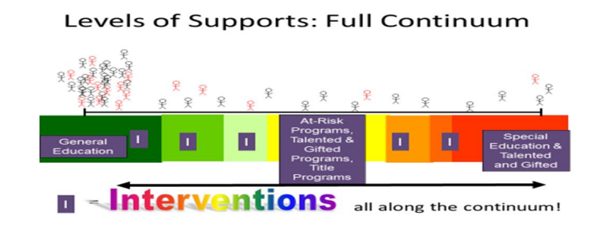

Evidence-based Interventions Resources
ESSA requires each SEA to describe its processes for approving, monitoring, and periodically reviewing LEA comprehensive support and improvement plans for selected schools. The NDDPI will offer a variety of additional supports to schools and LEAs that could include: on-site technical assistance, off-site networking sessions, embedded professional development, virtual learning experiences, guidance documents, and templates to support improvement planning and monitoring. The NDDPI will work with LEAs and REAs to support schools with implementing evidenced-based strategies. In addition, NDDPI will assist LEAs in exploring and identifying appropriate resources within the various national clearinghouses.

- What works Clearinghouse is a central source of scientific evidence for what works in education. (Institute of Education Sciences) http://ies.ed.gov/ncee/wwc/ IES Practice Guides are subjected to rigorous external peer review and consist of recommendations, strategies, and indications of the strength of evidence supporting each recommendation.
- Florida Center for Reading Research provides information about research-based practices related to literacy instruction and assessment for children preschool through 12th grade, as well as a variety of evidence-based interventions for use by educators. http://www.fcrr.org/
- Best Evidence Encyclopedia offers information to improve learning for students in grades K-12 and particularly targets students in mathematics, special needs/diverse learners, and English language learners. http://www.bestevidence.org/?ad=6
- The Center on Instruction offers information to improve learning in reading, mathematics, science, Special Education, and English Language Learning instruction.
- Center for Comprehensive School Reform and Improvement’s mission is to help schools organize, plan, implement, and sustain improvement.
- Evidence for ESSA, a free web site designed to provide education leaders with information on programs that meet the evidence standards included in the Every Student Succeeds Act (ESSA).

In ESSA, Section 1003(a) requires that schools selected for comprehensive and targeted support use their improvement funds only for interventions reflecting one of the highest three levels of evidence (Strong, Moderate, and/or Promising).
- Strong – at least one well-designed and well-implemented experimental study (e.g., a randomized controlled trial).
- Moderate – at least one well-designed and well-implemented quasi-experimental study.
- Promising – at least one well-designed and well-implemented correlation study with statistical controls for selection bias.

Based on an analysis of the needs assessment, the school and LEA must identify prioritized needs for each selected school in order to select the evidence-based strategies for their intervention plan. The development and implementation of the school and LEA intervention plan will include evidence-based strategies addressing student academic achievement and school success. The plan must reference the research supporting the selected evidence-based strategies in the appendix of the application.

Technical Assistance
The NDDPI has multiple ways of providing statewide technical assistance and sharing effective strategies for schools selected for Comprehensive or Targeted support. The following summarizes our key initiatives:

Extensive Website
The NDDPI, has developed an extensive website for schools and districts identified for improvement. This site contains a variety of resources including a link to all district and school accountability reports, information on reports due throughout the year, information, and application forms on additional funds available for schools, templates and sample reports, and resources and handouts from prior trainings.

Assigned NDDPI Division Liaison
The NDDPI, Division of Student Support and Innovation, assigns all schools a contact person for technical assistance and support throughout the school year. NDDPI staff will be responsible for reviewing all reports for the schools under their purview, in coordination with the SEA grant application review process. This ongoing, multi-tiered, detailed review process ensures the grantee is on the right track during the school and when closing out at the end of the program year. The liaisons keep in close contact with their assigned schools by gathering information, answering questions on issues, acting as a guidance coach, and tracking a school’s needs and efforts in a very comprehensive manner.

Monthly Research Report
The Division of Student Support and Innovation generates and distributes a monthly report which summarizes newly released research/resources on educational issues relevant to North Dakota schools. The monthly Research/Resource Report (RRR) is disseminated electronically to all principals, administrators, and Title I teachers and staff in schools approved for comprehensive and targeted support.

AdvancED Accreditation
The NDDPI requires statewide accreditation that is coordinated with AdvancED and monitored through a web-based tool, eProve. In order to streamline reporting the NDDPI supports consistency in plans and reduction in burden of paperwork through streamlining reports utilizing the AdvancED tool, eProve, to provide information regarding the schools needs assessment, programming, goals, activities, and plans to meet federal requirements and continuous improvement plans. The reports within the tool meet multiple reporting for state and federal programs including statewide accreditation, North Dakota approval process, Title I schoolwide plans, and continuous improvement plans.

Ed Direction and Frontline Education
School turnaround experts emphasize the importance of utilizing “skilled outside assistance to mount a comprehensive, sustained turnaround initiative” (Calkins, Guenther, Belfiore, & Lash, 2007. The Turnaround Challenge, p. 5, 2007). The NDDPI has partnered with the Ed Direction and Frontline Education as external partners to support NDDPI’s implementation of comprehensive support with impactful and expert services and resources. This partnership provides an opportunity for comprehensive support schools to contract services to support the state determined model and federal requirements which includes intensive support, coaching, professional development, evidence-based instructional strategies, data review/appraisals, and ongoing technical assistance. Ed Direction and Frontline together offer a Collaborative School Improvement Framework, a proven model designed to support underperforming schools. This systemwide model is built upon the belief that all students can master grade-level standards with scaffolding and support.
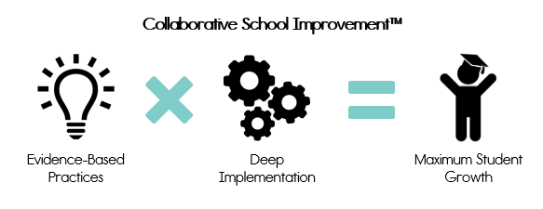
The strategies provided through this partnership include:

Assessment and Performance Measurement.
In our work across the country, we have learned that most educators care deeply about their students and want to increase learning in their classrooms. Yet, getting from the idea stage to implementation is a perennial problem. This implementation challenge is true of any change initiative. It is certainly not a unique feature of schools. For example, one member of our team has read enough books that she could probably teach a master class on healthy eating, yet her diet continues to mirror a 13-year old. Why? Because implementation on a consistent basis and at a durable level is super hard. We have found that keeping a narrow focus helps. In addition to the requirements of a comprehensive 3-year improvement plan and needs assessment and/or root-case analysis, we help schools to truly own their improvement efforts and systematically manage their progress:

- With our support, our partner schools conduct student engagement observations at regular intervals. This makes student learning visible, so schools can get a clear picture of the students’ reality in the classroom. These data are used to chart progress with instructional improvement efforts, provide opportunities for celebrations, and make necessary course corrections.

- Over the years, we have learned that expecting a community of educators, students, and families to keep close tabs on the implementation of a 3-year improvement plan is unrealistic. So, we work closely with the principal and School Transformation/Turnaround Team (i.e. a team of teacher leaders at the school) to narrow their focus and create 90-day plans that outline key targets for:
  - Student academic learning
  - Student social and emotional learning
  - Teacher learning
  - Implementation of agreed upon strategies included in 90-day plans

- Another example of our work with partner schools is quarterly reviews of implementation, these brief reports focus on the school’s identified strategies for implementation during the 90-day plan. Quarterly reviews are formative to the work of the turnaround school because they clearly identify successes, barriers to implementation and what has been done to address these barriers, and clear rationale for the strategies the school has selected.

Professional Learning.
Ed Direction and Frontline Education emphasize the importance of leveraging adult learners’ wealth of professional and life experience. “Adult learners have experiences that can be used as a foundation for learning new things . . . The particular life situations and perspectives that adults bring to the classroom can provide a rich reservoir for learning.” We value the diversity of experience our partner schools bring to the table, and our professional development taps into that experience to enrich the learning process through face-to-face, blended, and personalized learning options.. We know that “adult learners are busy, practical, and learn by doing. The learn best when there is immediate application for the learning; they participate actively in the learning process; [and] they can practice new skills or test new knowledge before leaving a learning session.” Our work consistently follows a Demonstration-Practice-Coaching approach that ensures educators develop a robust comprehension of material and learn how to implement skills in the moment so they can do so independently in the classroom or school setting.
We implement our professional learning standards, which are modeled after the research of Beverly Showers and Bruce Joyce who reported differing levels of transference of skills based upon the type of professional learning content and activities educators engaged in. In response to these and other data about implementation of professional learning, several years ago, we abandoned the notion that professional learning efficacy can be measured by the degree to which participants “liked” the session. We now focus on the level of implementation that the professional learning session supports, to enable implementation – we often say, “students cannot benefit from the interventions they don’t receive”. This shift to an implementation lens requires a different type of planning and delivery of professional learning content. The following table outlines the degree of transference found based upon the type of professional learning, as reported by the National Implementation Reseach Network (NIRN) Joyce and Showers:
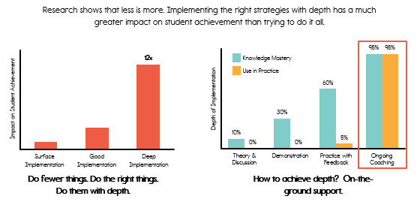

Coaching.
We wholeheartedly believe in coaching. In today’s world of work, coaching is almost universally employed to help people stay current and skill up, when needed. We believe that everyone deserves a coach who can give them feedback and support their individual learning. Our model for coaching is highly involved in the day-to-day realities of teachers. We get to work with you for a limited number of years, necessitating ample support for fluent implementation quickly and to scale.

    - Coaching includes observations, in-class modeling, co-teaching, co-planning, professional learning, and/or target feedback and goal setting. For the few schools where we are not on-site every week, we employ the use of technology to touch each teacher. Our Collaborative Coaching model is focused on evidence, principles of reciprocity, and a genuine belief in the capacity of professional educators to learn and grow. For what it’s worth, we believe we are learners during coaching sessions, too. Schools teach us a lot.
    - We also understand that instructional leadership is complex and absolutely necessary for school improvement. Consequently, we engage in weekly, twice-monthly, and monthly coaching sessions with principals, they pick the frequency based upon their schedule and current needs.

    - Ed Direction and Frontline Education are nationally known for providing schools with the tools and supports necessary to make lasting improvement a reality. We have learned that this often requires work with central district and charter offices and school boards. Ed Direction wrote Collaborative School Improvement (Harvard Press) to encourage the employment of proven strategies for effective district office-school partnerships. We engage with the district or charter board monthly or quarterly, depending on the selected level of support (i.e., Tier 1, 2, or 3). We embrace the opportunity to work with central district offices and charter leadership because we see a real opportunity to create stronger systems of communication and support between school boards and the schools they are charged with serving.

Together, Ed Direction and Frontline Education will provide virtual and onsite-specific supports for schools. Each school will have a customized service delivery schedule that includes coaching and consultation with ongoing feedback and recommendations for extended learning and collaboration utilizing evidence-based and on-demand professional learning resources. These resources include virtual coaching, structures for job-embedded professional learning, observations to provide actionable feedback, and recommendations for implementation of instructional strategies and materials, as needed.

Department Sponsored Conferences
The NDDPI sponsors several conferences each year. Each spring, regional trainings are held for schools and districts to disseminate key information regarding the supports, services, and requirements as well as to share effective strategies for making progress. In the fall, a statewide conference is held for educators to promote effective evidence-based strategies designed to raise achievement. The NDDPI sponsors webinar presentations specifically designed to provide technical assistance and guidance to comprehensive support schools. Numerous other trainings, via conference call or webinars, are also offered each year to share and disseminate information statewide. Time that staff spends providing technical assistance to comprehensive support schools will be coded to administrative funds.

Webinar Trainings
To further expand the number of training opportunities available to educators, the NDDPI periodically conducts webinar trainings on relevant educational issues. This form of training is very beneficial because the trainings are short (one hour), easy to access, and participants don’t have to be away from their building. In addition, each training is recorded for viewing at times convenient for school personnel. All trainings the NDDPI will hold for the comprehensive schools will be conducted through webinar trainings. SEA grant funds will be used to provide statewide technical assistance for these key initiatives.

Sharing of Effective Strategies
The NDDPI frequently collaborates with educational entities to create resources for North Dakota schools and districts. We believe it is critical to highlight what has been proven to be effective across North Dakota.

Within North Dakota’s original ESEA Flexibility Waiver application, states had to create intervention charts and identified priority and focus schools would have been required to submit an improvement plan to the NDDPI identifying interventions that will be implemented to address the identified needs and challenges at the school. Over the next year, NDDPI will be working with the North Central Comprehensive Center (NCCC) and the Regional Education Laboratory at Marzano Research to reinvent and update intervention charts for four specific categories of students that outline and list evidence-based strategies and interventions. Within our state plan, there will be four charts providing a menu of interventions for schools to reference.

The interventions will be separated into categories, which include:
- Interventions for Low Achieving Students
- Interventions Geared for English Learners (EL) Students
- Interventions Geared for Native American Students
- Interventions Geared for Students with Disabilities

Schools selected for comprehensive and targeted support can select interventions from the state generated list or select other interventions of their choice. These schools will outline their selected interventions in their improvement plan, as well as on the Consolidated Application for Federal Title Funding.

Hattie, J. (2013). Visible learning for teachers: Maximizing Impact on Learning. Retrieved April 11, 2018: https://us.corwin.com/en-us/nam/visible-learning-for-teachers/book243115
Hattie, J. (2009). Visible learning: A synthesis of over 800-meta-analyses relating to achievement. Retrieved April 12, 2018: https://visible-learning.org/
Marzano Research. Retrieved April 12, 2018: https://www.marzanoresearch.com/research/reports?dir=desc&order=publication_date
Robionson, V. (2011). Student-centered leadership. Retrieved April 12, 2018: https://books.google.com/books?hl=en&lr=&id=6Xy1dtzoZjQC&oi=fnd&pg=PA1&dq=student+centered+leadership&ots=tcy5Eof133&sig=m3dgnHY2UuW-G3bzyb2Ir6EomLA#v=onepage&q=student%20centered%20leadership&f=false
Stanovich, P. J. & Stanovich, K. E. (2003). Using research and reason in education. Retrieved April 12, 2008: https://lincs.ed.gov/publications/pdf/Stanovich_Color.pdf
Best Evidence Encyclopedia. Retrieved April 12, 2018: http://www.bestevidence.org/
Rosenshine, B. (2012). Principles of instruction: Research-based strategies that all teachers should know. American Educator (spring). Retrieved April 11, 2018: https://www.aft.org/sites/default/files/periodicals/Rosenshine.pdf
Ericsson, A. & Pool, R. (2016). Peak: Secrets from the new science of expertise. Retrieved April 12, 2018: https://books.google.com/books/about/Peak.html?id=GmcpCgAAQBAJ&printsec=frontcover&source=kp_read_button#v=onepage&q&f=false
Marzano Research. Retrieved April 12, 2018: https://www.marzanoresearch.com/research/reports?dir=desc&order=publication_date
I bid.
U.S. Department of Education. (2016). Non-regulatory guidance: Using evidence to strengthen education investments. Retrieved April 12, 2018: https://www2.ed.gov/policy/elsec/leg/essa/guidanceuseseinvestment.pdf
What Works Clearinghouse.Retrived April 12, 2018: https://ies.ed.gov/ncee/wwc/
National Reading Panel. (2000). Final report. Retrieved April 12, 2018: https://www.nichd.nih.gov/research/supported/nrp
http://www.readingrockets.org/article/what-guided-oral-reading
http://oregonreadingfirst.uoregon.edu/downloads/instruction/big_five/dynamic_vocab_aa.pdf
file:///C:/Users/mtsagaris/AppData/Local/Microsoft/Windows/INetCache/Content.Outlook/5YYH708U/contextclues.pdf
http://www2.ed.gov/programs/readingfirst/support/rmcfinal1.pdf
For ELs whose language shares cognates with English, cognate awareness is an important strategy as students can draw on their cognate knowledge as a means of figuring out unfamiliar words in English: http://www.readingrockets.org/article/teaching-vocabulary
http://www.rtinetwork.org/essential/tieredinstruction/tier1/effectiveteaching
“Using Adult Learning Principles in Adult Basic and Literacy Education,” Susan Imel, 1998, Practice Application Brief, Clearinghouse on Adult, Career, and Vocational Education, The Ohio State University, http://www.calpro-online.org/ERIC/textonly/docgen.asp?tbl=pab&ID=88.
“Facilitating Adult Learning: How to Teach so People Learn,” Dr. Lela Vandenberg, Michigan State University, p. 2, http://od.msue.msu.edu/uploads/files/PD/Facilitating_Adult_Learning.pdf.
Showers, B., & Joyce, B. (1996). The evolution of peer coaching. Educational Leadership, 53(6), 12-16.
I bid.

